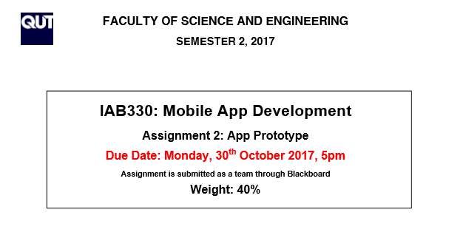

**DECLARATION**

You must sign below. By signing this form, you agree to the following:

* We declare that all the work submitted for this assignment is our own original work except for material that is explicitly referenced and for which we have permission, or which is freely available (and also referenced)

The assignment shall be conducted in a team of 4 students, each team member must sign as it is a formal agreement that represents that everyone is contributing to the whole assignment.

|  |  |  |
| --- | --- | --- |
| **Team Member Details** | | |
| **Student Number** | **Student Name** | **Signature** |
| N9665072 | Gyeongmin Jee | **https://docs.google.com/drawings/d/sXOFJMUoM0VmUFJOfetqPlg/image?w=75&h=32&rev=8&ac=1** |
| N6903495 | David Nguyen | **https://docs.google.com/drawings/d/sO9T2v_yV0jfGRNQcOvYDrg/image?w=123&h=35&rev=9&ac=1** |
| N9345311 | Quang-Cheng Tsui |  |
| N9686801 | Yusef Acabani | **C:\Users\Lenovo\AppData\Local\Microsoft\Windows\INetCache\Content.Word\44aa9f83-a630-4bc6-a2ea-553591823b74.png** |
| **URL LINK TO PRESENTATION: can make a shareable google drive link?** | | |

Contents

1. Introduction to “Where’s My Stuff?” 3

2. User Interface 3

2.1. UI Patterns and Design Considerations 3

2.1.1. Updated UI 3

2.1.2. Page Navigation 3

2.1.3. Colour Scheme/Theme 3

2.1.4. Form Patterns 3

2.2. Home Page 4

2.3. Add Room 5

2.4. Box Management 6

2.5. Searching and Adding Items 6

2.6. Help Section 6

2.7. List of Required Features 7

2.7.1. Saving Items into Boxes 7

2.7.2. Searchable Database 7

2.7.3. Listing Boxes and its Contents 7

2.7.4. Categorised Items by Room Types????wth is this? 7

2.7.5. Moving????wth is this too? 7

2.7.6. Move Items Between Boxes 7

2.7.7. Creating Box Labels 7

2.8. Nice-To-Have Features 7

3. Software Architecture 7

3.1. Discussion of Software Architecture Adopted 7

3.2. Discussion of Applied Software Architectural Patterns 7

3.3. Implementation of Functionality of Each Component and Class 7

4. Testing and Quality Assurance Strategy 7

4.1. Discussion of Quality Assurance 7

4.2. Discussion of Testing Methodology 7

5. Reflection on Learning 7

# Introduction to “Where’s My Stuff?”

Ever have problems finding items in boxes which you’ve stored for various reasons such as moving houses or putting away for long-term storage? That is the problem in which “Where’s My Stuff?” aims to solve. “Where’s My Stuff?” is an application for smart devices which allows users to record and track which items are stored in which boxes thus, makes searching for items simpler. A lot of consideration was taken into the design of this application and that is what this report will discuss. In particular, the report will present discussions on how to use the application, the user interface design considerations, application functionality, the software architecture (in particular the MVVM architecture), implemented quality assurance strategies, testing methodologies and learning outcomes.

# User Interface

## UI Patterns and Design Considerations

### Updated UI

Similar to conceptual designs (As submitted previously), the overall look of the application was kept relatively familiar. The Home Page acts as the primary navigation menu and utilises the list menu view. Some of the navigation buttons were however changed since conceptual design. The addition of the Add/Remove Room button now allows users to create their own rooms for which boxes will be stored. This feature will be explained further shortly. Additionally, there is a margin applied left and right and is uniform across all screen. This will assist in making the pages look neater and better presented.

### Page Navigation

Page navigation has also been slightly altered. The new page navigation hierarchy is presented in Figure 1.

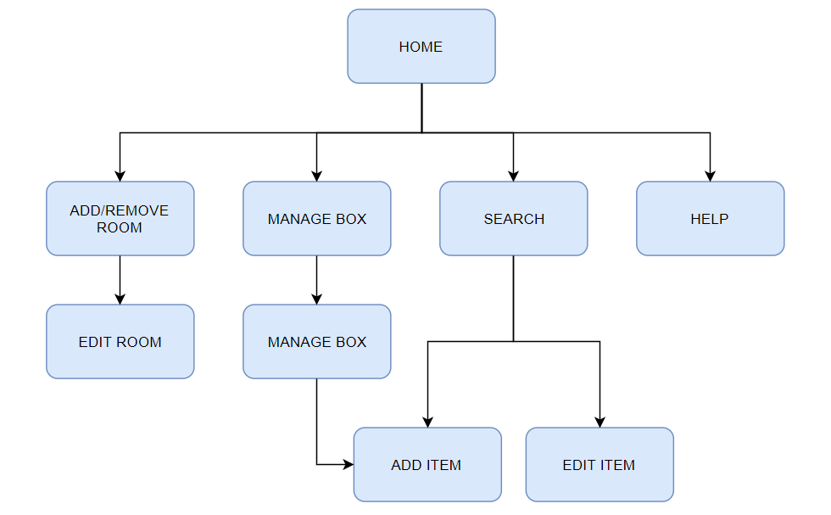

Figure 1. Updated Page Navigation Hierarchy

### Colour Scheme/Theme

The colour theme is very simple yet colourful. The home page will consist of different colours for the buttons and act as an indicator for which page it navigates to (e.g. the “Add Room” button is lime; therefore, the Add Room Page will also have lime accents). The background will be consistent among all pages with a white background and a dark grey navigation bar at the top.

### Form Patterns

The key factors to consider with forms is to make sure the forms are illustrated effectively, not cluttered and simple to comprehend. The primary form patterns used for this application include the search and registration form patterns. Where applicable, the text entry fields and picker items will be applied to pages and its forms. These can be seen in the following several sections which discusses each page and its functionality.

## Home Page

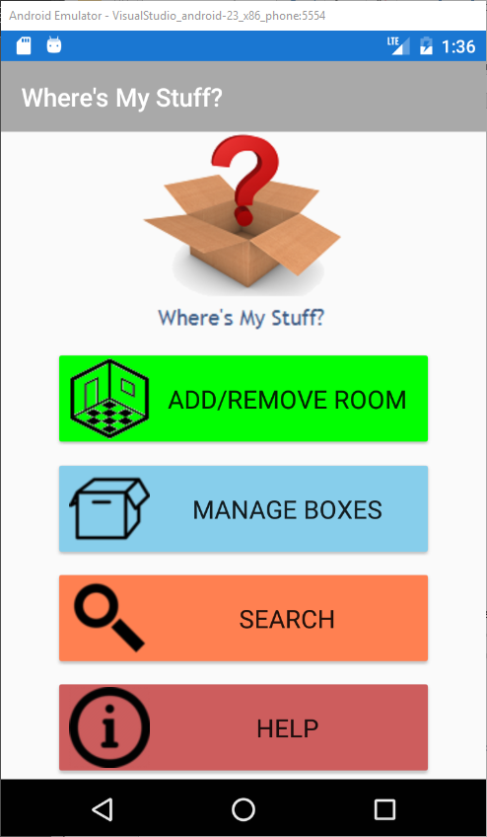

Figure 2. Screenshot of Home Page

The Home Page is the primary navigation for the “Where’s My Stuff?” application. As mentioned previously, it displays a simple list layout with minimal options on the page, to not overwhelm users. Note that the colour of each button also indicates the colour of that particular page (which was done to follow the colour theme mentioned previously) which will be demonstrated in the following sections.

## Add Room

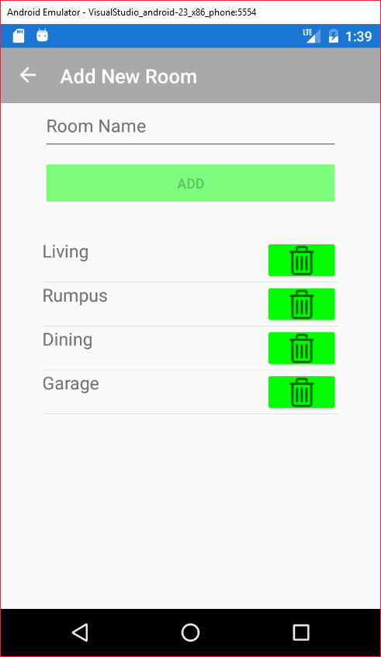

Figure 3. Screenshot of Add Room Page

Adding a room is a new feature added since the conceptual design. This page allows users to generate their own room types and thus allocate boxes to those rooms. Users will also not be able to generate duplicates. Therefore, users can only have one name for each room type. For example, if a room type “Garage” is already existing as shown in Figure 3, users cannot add another room called “Garage”. If users attempt to create duplicates, the application will display an alert notifying the user of this issue. Whilst on this page, users can also choose to delete any room type by simply tapping the bin icon for the respective room. Clicking the bin icon will prompt the user with another alert which will ask users to confirm their actions before deleting the room type.

## Box Management

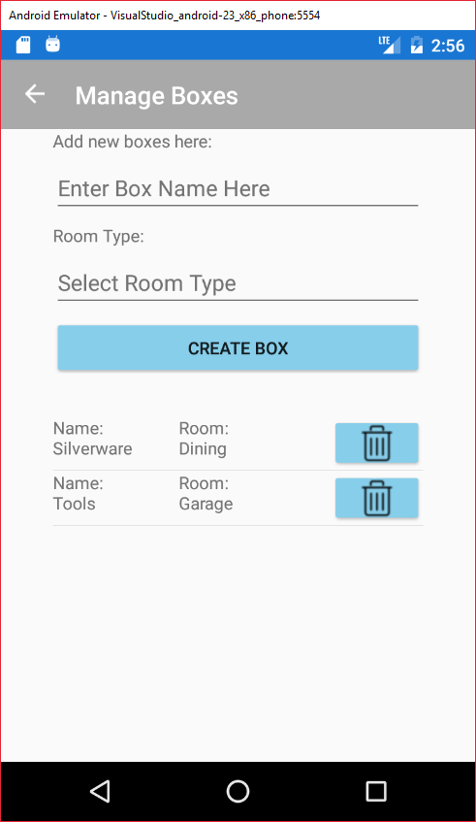 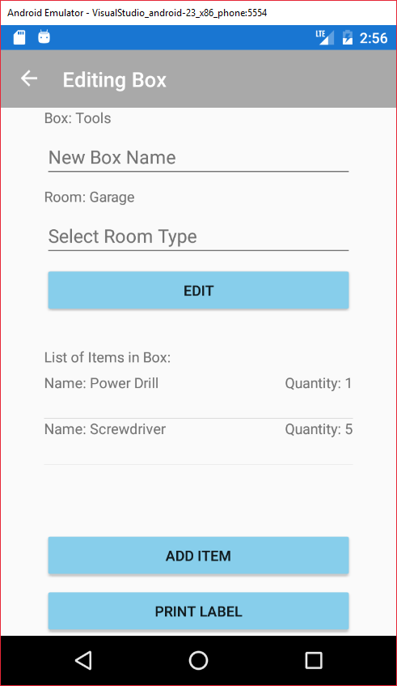

Figure 4. Screenshot of (Left to Right) Manage Box Page and Edit Box Page

Managing boxes can be achieved by selecting the “Manage Boxes” button whilst on Home Page. From here, users can see the list of available boxes as well as generate a box by assigning it a name and room (as illustrated in Figure 4). Users can also delete any box by tapping the bin icon which also displays an alert window for users to confirm their actions. Editing a box can be accomplished by tapping on the box users wish to edit. Whilst on the Edit Box page, users can change the box’s name as well as room type then tapping “Edit” to confirm the changes. Whilst on this page, users can also see all items present in the current box as well as the option to add new items or print a label displaying the box’s name, room type and list of contents.

## Searching and Adding Items

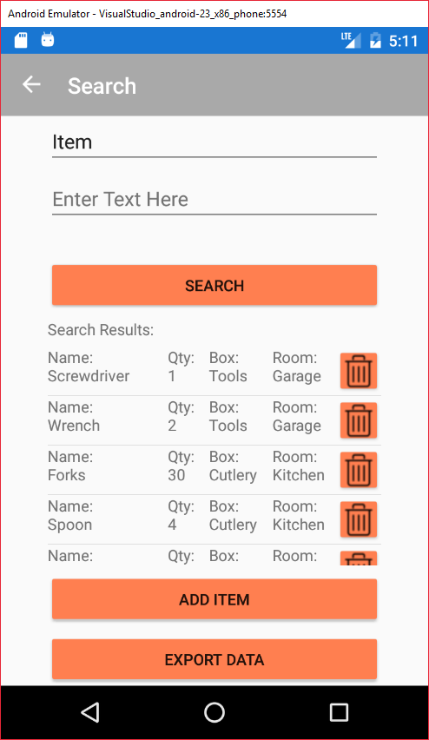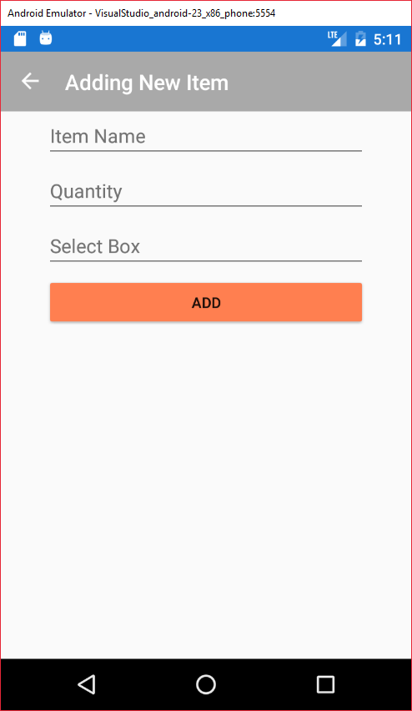

Figure 5. Screenshot of (Left to Right) Search Page and Add Items Page

When first entering the search page, users will be able to see all items currently saved in the database. To search for items, users can use the drop-down menu at the top of the screen to select to search by item name, room type and box name. Users can also edit an item from this page by tapping an item. If users want to add a new item, they can click “Add Item” button at the bottom to navigate to the “Add Items” page.

## Help Section

The Help Page is reachable via tapping the “Help” button whilst on the Home Page. The Help Page serves as a how-to guide for users to get into using the application. It provides step by step instructions on how to achieve whatever tasks the user requires of the application.

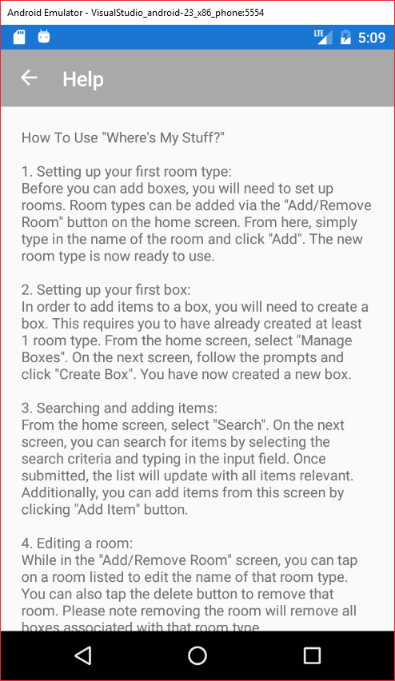

Figure 6. Screenshot of Help Page

## List of Required Features

### Saving Items into Boxes

### Searchable Database

### Listing Boxes and its Contents

### Categorised Items by Room Types????wth is this?

### Moving????wth is this too?

### Move Items Between Boxes

### Creating Box Labels

The application was made to allow users to generate a simple text file which they can print to apply to a box.

## Nice-To-Have Features

### Data Export

# Software Architecture

## Discussion of Software Architecture Adopted

## Discussion of Applied Software Architectural Patterns

## Implementation of Functionality of Each Component and Class

(Should mention the packages used for this application if applicable)

# Testing and Quality Assurance Strategy

## Discussion of Quality Assurance

## Discussion of Testing Methodology

# Reflection on Learning